Week | Assignment | Using  Kit # | Forms due | Reports  due
1 | - | - | - | -
2 | 1B | 1 | C14, C16, C18, C20 | -
3 | 2A | 2 | C16, C18, C20, C25, C27, C29 | R1, R2
4 | 2B | 3 | C16, C18, C20, C25, C27, C29 | R3
5 | 3B | 4 | C16, C18, C20, C27, C29, C34, C37, C39 | -
6 | 4B | 5 | C16, C18, C20, C27, C29, C37, C39, C45, C47, C49 | -
7 | 5B | 6 | C16, C18, C20, C27, C29, C37, C39, C45, C47, C49 | -

Physical & Logical LOC Results

Program 1B
org.greg.drexel.b1.Main.java
- Physical LOC: 109
- Logical LOC: 32

org.greg.drexel.b1.gui.MainFrame.java
- Physical LOC: 296
- Logical LOC: 90

org.greg.drexel.b1.types.FileModeType.java
- Physical LOC: 32
- Logical LOC: 10

org.greg.drexel.b1.io.MyFileReader.java
- Physical LOC: 65
- Logical LOC: 13

org.greg.drexel.b1.io.MyFileWriter.java
- Physical LOC: 64
- Logical LOC: 12

Program 2A
org.greg.drexel.a2.loc.CountingStandard.java (Added from 1B)
- Physical LOC: 109
- Logical LOC: 33 (All 33 LOC added)

org.greg.drexel.a2.loc.LOCCounter.java (Added from 1B)
- Physical LOC: 87
- Logical LOC: 20 (All 20 LOC added)

org.greg.drexel.b1.Main.java (Modified from 1B)
- Physical LOC: 108
- Logical LOC: 41 (1B: 32, so 41-32 = 9 LOC added)

org.greg.drexel.b1.gui.MainFrame.java (Modified from 1B)
- Physical LOC: 174
- Logical LOC: 55 (1B: 90, so 90-55 = 35 LOC deleted)

org.greg.drexel.b1.io.MyFileReader.java (Untouched from 1B)
- Physical LOC: 65
- Logical LOC: 13 (Same LOC from 1B, untouched code)

org.greg.drexel.b1.io.MyFileWriter.java (Modified from 1B)
- Physical LOC: 64
- Logical LOC: 12 (Same LOC from 1B, only modified LOC)

Note: Completely removed org.greg.drexel.b1.types.FileModeType.java from 1B (10 LOC deleted)

Program 2B
org.greg.drexel.b1.Main.java (Modified from 1B)
- Physical LOC: 147
- Logical LOC: 46 (1B: 32, so 46-32 = 14 LOC added)

org.greg.drexel.b1.gui.MainFrame.java (Modified from 1B)
- Physical LOC: 478
- Logical LOC: 148 (1B: 90, so 148-90 = 58 LOC added)

org.greg.drexel.b1.io.MyFileReader.java (Untouched from 1B)
- Physical LOC: 65
- Logical LOC: 13 (Same LOC from 1B, untouched code)

org.greg.drexel.b1.io.MyFileWriter.java (Modified from 1B)
- Physical LOC: 64
- Logical LOC: 11 (1B: 12, so 12-11 = 1 LOC deleted)

org.greg.drexel.b1.types.FileModeType.java
- Physical LOC: 33
- Logical LOC: 11 (1B: 12, 1 LOC added)

org.greg.drexel.b1.types.FileModifyType.java (New in 2B)
- Physical LOC: 35
- Logical LOC: 13 (All 13 lines added, new class)

Program 3B
org.greg.drexel.b1.Main.java (Untouched from 2B)
- Physical LOC: 147
- Logical LOC: 46

org.greg.drexel.b1.gui.MainFrame.java (Modified from 2B)
- Physical LOC: 484
- Logical LOC: 151 (2B: 148, so 151-148 = 3 LOC added)

org.greg.drexel.b1.io.MyFileReader.java (Untouched from 2B)
- Physical LOC: 65
- Logical LOC: 13

org.greg.drexel.b1.io.MyFileWriter.java (Untouched from 2B)
- Physical LOC: 64
- Logical LOC: 11

org.greg.drexel.b1.types.FileModeType.java (Untouched from 2B)
- Physical LOC: 33
- Logical LOC: 11

org.greg.drexel.b1.types.FileModifyType.java (Untouched from 2B)
- Physical LOC: 35
- Logical LOC: 13

Program 4B
org.greg.drexel.b1.Main.java
- Physical LOC: 202
- Logical LOC: 68 (4+8+8+8=28 LOC added, 1 LOC modified, 3+3=6 LOC deleted)

org.greg.drexel.b1.gui.MainFrame.java
- Physical LOC: 511
- Logical LOC: 169 (18 LOC added, 1 LOC modified)

org.greg.drexel.b1.io.MyFileReader.java (Untouched from 3B)
- Physical LOC: 65
- Logical LOC: 13

org.greg.drexel.b1.io.MyFileWriter.java (Untouched from 3B)
- Physical LOC: 64
- Logical LOC: 11

org.greg.drexel.b1.types.FileModeType.java (Untouched from 3B)
- Physical LOC: 33
- Logical LOC: 11

org.greg.drexel.b1.types.FileModifyType.java (Untouched from 3B)
- Physical LOC: 35
- Logical LOC: 13

Program 5B
org.greg.drexel.b1.Main.java
- Physical LOC: 237
- Logical LOC: 80 (12 LOC added, 4 LOC modified)

org.greg.drexel.b1.gui.MainFrame.java
- Physical LOC: 552
- Logical LOC: 185 (20 LOC added, 9 LOC modified, 4 LOC deleted)

org.greg.drexel.b1.io.MyFileReader.java
- Physical LOC: 69
- Logical LOC: 15 (2 LOC added, 4 LOC modified)

org.greg.drexel.b1.io.MyFileWriter.java
- Physical LOC: 86
- Logical LOC: 18 (7 LOC added, 1 LOC modified)

org.greg.drexel.b1.types.FileModeType.java (Untouched from 4B)
- Physical LOC: 33
- Logical LOC: 11

org.greg.drexel.b1.types.FileModifyType.java (Untouched from 4B)
- Physical LOC: 35
- Logical LOC: 13
Totals
Program 1B
- Physical LOC: 626
- Logical LOC: 157
Program 2A
- Physical LOC: 607
- Logical LOC: 174
Program 2B
- Physical LOC: 822
- Logical LOC: 242
Program 3B
- Physical LOC: 828
- Logical LOC: 245
Program 4B
- Physical LOC: 910
- Logical LOC: 285
Program 5B
- Physical LOC: 1012
- Logical LOC: 324 (41 LOC added, 18 LOC modified, 4 LOC deleted)

Note: Assignment 4B was SVN merged into Assignment 5B.
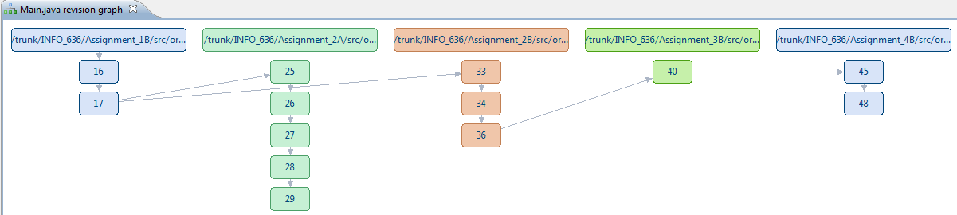
Program 5B Screenshots
Screenshots during testing

Table 1. Input for the test cases
Program Number | Estimated (N) LOC | Actual (N) LOC | Estimated Time  (min) | Actual Time  (min)
1.2 (1B) | 200 | 157 | 300 | 186
2.1 (2A) | 60 | 92 | 221 | 406
2.2 (2B) | 70 | 81 | 313 | 560
3.2 (3B) | 5 | 4 | 116 | 132
4.2 (4B) | 53 | 43 | 175 | 195
5.2 (5B) | 39 | 57 | 105 | 179

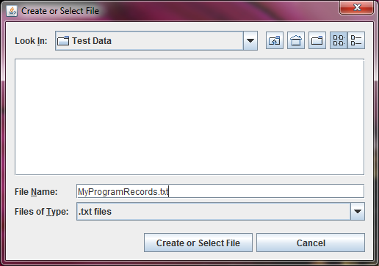
Figure 1. Select a new file to write

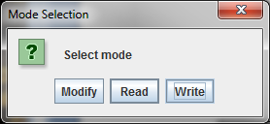
Figure 2. Select write mode

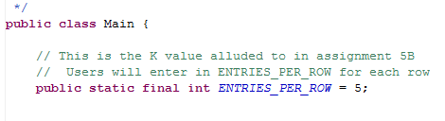
Figure 3. Note how ENTRIES_PER_ROW is 5 (5 columns of data)

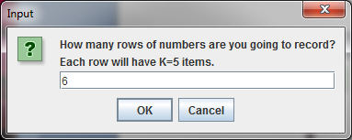
Figure 4. System asks how many rows to insert, user inputs 6

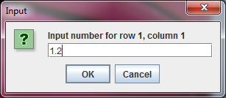
Figure 5. User is asked for input

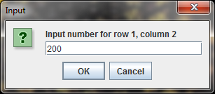
Figure 6. User is asked for input

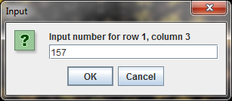
Figure 7. User is asked for input

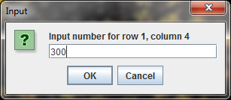
Figure 8. User is asked for input

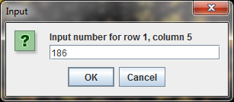
Figure 9. User is asked for input

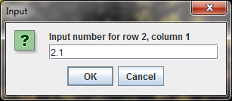
Figure 10. User is asked for input for second row of data

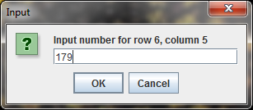
Figure 11. User is asked for input for last row, last column of data

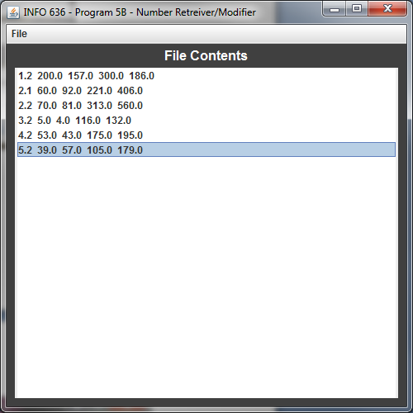
Figure 12. System displays user input

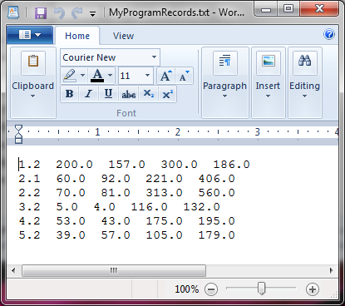
Figure 13. System saves file MyProgramRecords.txt

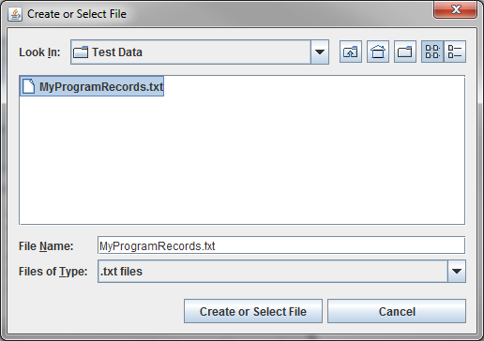
Figure 14. System can open the saved file

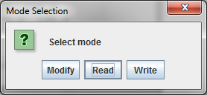
Figure 15. User selects read mode to read saved file

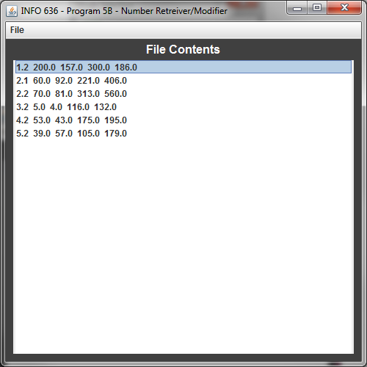
Figure 16. Saved file is opened for reading
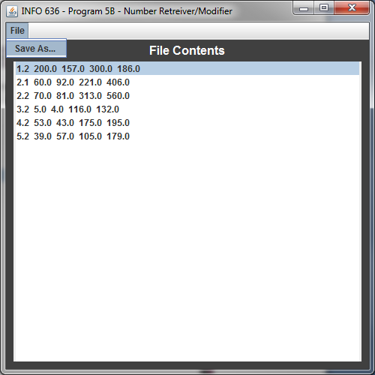
Figure 17. User tries to use Save As functionality

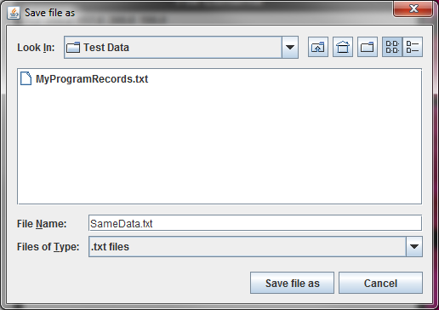
Figure 18. File is saved as another name SameData.txt

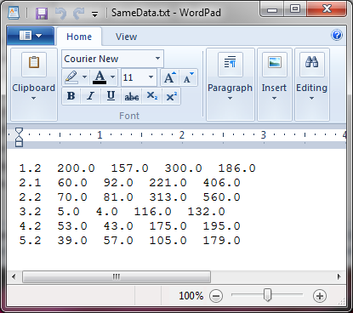
Figure 19. Save As functionality saves data to another file

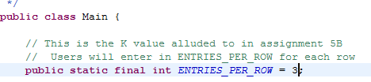
Figure 20. User changes K/ENTRIES_PER_ROW value to 3

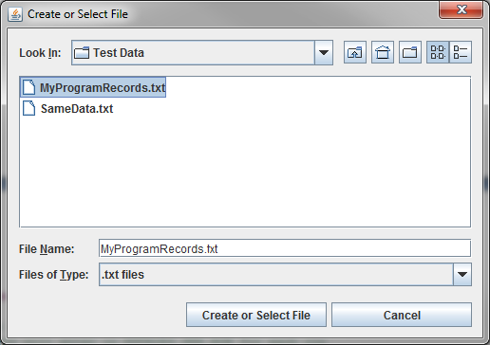
Figure 21. The same file is selected for reading

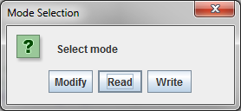
Figure 22. Read mode selected

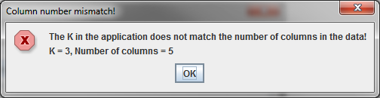
Figure 23. Because the K value was set to 3 but the file has 5 columns, the user is prompted by an error and the system exits
Table C16: Time Recording Log

Student |  | Greg Vannoni |  |  |  |  | Date | 2/20/10
Instructor |  | Glenn Booker |  |  |  |  | Program # | 5B
Date | Start | Stop | Interruption  Time | Delta  Time | Phase | Comments
2/20 | 10:00a | 10:40a | 2 | 38m | PLANNING | Filled out planning forms
2/20 | 10:41a | 11:00a | 0 | 19m | DESIGN
2/20 | 11:01a | 11:29a | 3 | 25m | CODE | All done except for making GUI display data as 2D
2/20 | 11:30a | 11:31a | 0 | 1m | COMPILE
2/20 | 11:32a | 11:30a | 0 | 8m | TEST | Finished testing everything but GUI display, file read/write works
2/20 | 11:31a | 11:40a | 0 | 9m | CODE | Made GUI display data as 2D array with rows/columns
2/20 | 11:41a | 11:42a | 0 | 1m | COMPILE
2/20 | 11:43a | 11:46a | 0 | 3m | TEST | Tested GUI display
2/21 | 12:10p | 1:30p | 5 | 75m | PM | All done with documents!

Table C18 Defect Recording Log
Defect Types
10 Documentation 60 Checking
20 Syntax 70 Data
30 Build, Package 80 Function
40 Assignment 90 System
50 Interface 100 Environment
Student |  |  |  | Greg Vannoni |  |  |  |  |  |  |  | Date |  | 2/20/10
Instructor |  |  |  | Glenn Booker |  |  |  |  |  |  |  | Program # |  | 5B
Date |  | Number |  |  |  | Type |  | Inject |  | Remove |  |  | Fix Time |  | Fix Defect
2/20 |  | 1 |  |  |  | 60 |  | code |  | test |  |  | 2
 |  |  | Delete operation not working when using Modify mode because I was trying to remove
an Object as an ArrayList instead of as a String - updated removeSingleRow
Date |  | Number |  |  |  | Type |  | Inject |  | Remove |  |  | Fix Time |  | Fix Defect
Description:
Date |  | Number |  |  |  | Type |  | Inject |  | Remove |  |  | Fix Time |  | Fix Defect
Description:
Date |  | Number |  |  |  | Type |  | Inject |  | Remove |  |  | Fix Time |  | Fix Defect
Description:
Date |  | Number |  |  |  | Type |  | Inject |  | Remove |  |  | Fix Time |  | Fix Defect
Description:
Date |  | Number |  |  |  | Type |  | Inject |  | Remove |  |  | Fix Time |  | Fix Defect
Description:
Date |  | Number |  |  |  | Type |  | Inject |  | Remove |  |  | Fix Time |  | Fix Defect
Description:

Table C27 Process Improvement Proposal (PIP)

Student | Greg Vannoni |  | Date | 2/20/10
Instructor | Glenn Booker |  | Program # | 5B
Process | PSP1.1 | Elements

PIP Number
 |  | Problem Description:
1 |  | I've noticed that my time estimates with C39 have a very large variance
 |  | C39 is misleading with this class because it only accounts for CODE
 |  | and not for the other phases (PLAN, DESIGN, COMPILE, TEST, PM).
 |  | This isn't good because the time estimates I'm putting into C39
 |  | are for the complete time it takes me to do a homework assignment.
PROPOSAL
PIP # |  | Proposal Description
1 |  | Modify C39 to only account for CODE time (and not total time for
 |  | all phases) - This relates new and changed LOC to the actual time
 |  | it takes only for coding, so this is a really good idea.
Notes and Comments:
 |  | In fixing C39 as described above, my time estimates are now A TON more
 |  | valid. In using the total time for all phases, the estimated time to
 |  | develop E=27 LOC was around 100 minutes, after fixing C39 I now
 |  | have a legitimate estimate for estimated total development time of 41 min
 |  | which is a lot more believable.
 |  | The proof of higher accuracy also shows in the standard deviation (398 for program 4B and 140 for program 5B), variance, range, etc.
 |  | Update (2/21): I guess I can't do this for the project so everything is switched back.

Table C37 Test Report Template

Student | Greg Vannoni | Date | 2/20/10
Instructor | Glenn Booker | Program # | 5B

Test Name/Number | Test Case #01 - Read functionality
Test Objective | Determine if there has been regression to Read functionality and determine if error checking is performed on the selected file
Test Description | This function has not changed since Program 3B, ensure
 | ensure that the user can still read the file like in 3B, also
 | ensure that if the user enters a file that doesn't exist, they
 | are given an error message
Test Conditions | 1. File may already exist with real numbers
Expected Results | 1. File selected and displayed in JList just like in
 | Program 3B
 | 2. Non-existent file is selected, user is presented with error dialog explaining the situation and may either continue (by selecting an existing file) or terminate the program
Actual Results | Success. Program displayed file just like Program 3B.
 | When an invalid file was selected, user was presented
 | with dialog box as described in expected results.
Test Name/Number | Test Case #02 - Write functionality
Test Objective | Ensure write functionality from 3B still exists and that a warning message is displayed when the user attempts to write to a file that already exists.
Test Description | 1. Ensure that write functionality has not regressed since 3B
 | 2. Ensure that new warning dialog box is displayed
 | when a number is not properly input to system.
 | 3. Ensure that a dialog box is presented to the user when they select a file that already exists.
Test Conditions | None
Expected Results | 1. File should be written to selected directory just like 3B
 | 2. If invalid input is given, a dialog box should appear that allows the user to continue (retry) or exit the application.
 | 3. If the user selects an already existing file, a dialog box should appear which will allow the user to continue (by re-entering another non-existent file) or terminate the program
Actual Results | Success. No regression to write capability, dialog box with
 | "Ok" and "Terminate Application" are displayed when
 | invalid number (integer when asked for quantity of
 | numbers and double/real number when asked for number
 | input.
Test Name/Number | Test Case #03 - Modify functionality
Test Objective | Ensure that there has been no regression in modify functionality and that the user can only select from the options in program 3B.
Test Description | 1. Validate that no functionality has changed since 3B
 | 2. Select the "Insert" button after the "Modify" mode is selected and validate that invalid number input (for real numbers) has the Program 4B warning message to the user.
 | 3. Ensure that when the user selects a non-existent file to modify they are presented with a dialog box in which they can continue or terminate the application
 | 4. Ensure that rows are displays as full rows showing 2D support. The modify feature should allow for manipulation of complete rows, not single elements.
Test Conditions | User must select "Modify" mode to be presented with
 | modify functionality
Expected Results | 1. If the user selects the "Insert" mode, and inserts a non-real number, a warning dialog should be displayed.
 | 2. All existing 3B functionality for Accept, Accept All, Replace and Delete should exist unmodified.
 | 3. If a user selects a file that doesn't exist for modification, they should be presented with a dialog box which will allow them to continue (select another file to modify) or terminate the application.
 | 4. When selecting any button, it should treat the entire 2D row as one entity, thus the "delete" button deletes the entire row, "insert" inserts an entire row with K columns, "replace" asks to replace every K columns and accept/accept all show an entire row
Actual Results | Successful, all tests passed.
Test Name/Number | Test Case #04 - File name validity check
Test Objective | Ensure the filename a user selects is valid (per Windows filename validity checks)
Test Description | 1. If a user inputs the characters \ / : * ? " < > |, a dialog box should be displayed to inform the user of an invalid file name.
Test Conditions | Java's JFileChooser may auto-correct some filenames, however, in most cases, any filename with the invalid characters as stated above should be caught.
Expected Results | 1. If the user has any characters listed above in the filename, it should be treated as invalid alerting the user as such.
Actual Results | Successful, all tests passed.
Test Name/Number | Test Case #05 - System should ask for K items per row of input
Test Objective | Depending on the compile value of ENTRIES_PER_ROW in Main.java, the system should ask the user for the number of rows * ENTRIES_PER_ROW of numbers
Test Description | 1. If a user elects to insert 3 rows, they should be prompted for 3 * ENTRIES_PER_ROW (currently set to 5) numbers to input, or more generally userInput * ENTRIES_PER_ROW
Test Conditions | The ENTRIES_PER_ROW variable must be greater than 0
Expected Results | 1. If 3 is the number of rows to input and ENTRIES_PER_ROW is 5, then the user should be asked for 15 numbers.
Actual Results | Successful, all tests passed.
Test Name/Number | Test Case #06 - Read/Write 2D Array
Test Objective | The file should be stored and displayed as a 2D array with rows and columns of data
Test Description | 1. When performing a Save As, or write operation the file created should be in a 2D array with rows and columns of numbers.  2. When opening a file using the read option, it should be displayed in a 2D format with more than one item per row and with more than one column.
Test Conditions | A valid file must be selected for writing or reading
Expected Results | 1. File displayed as 2D array with more than one row and column  2. File saved as 2D array with more than one row and column
Actual Results | Successful, all tests passed.
Test Name/Number | Test Case #07 - Column number mismatch
Test Objective | If K (ENTRIES_PER_ROW) does not match the number of columns during a Read or Write operation, the user should be informed.
Test Description | 1. When Reading or Modifying a file, if the file does not have the same number of columns as ENTRIES_PER_ROW in Main.java, the program should exit.
Test Conditions | A valid file must be selected for reading or modification
Expected Results | 1. User is presented with error dialog explaining that the number of columns in their file does not match K (ENTIRES_PER_ROW in Main.java)
Actual Results | Successful, all tests passed.

Table C39 Size Estimating Template
SEE SPREADSHEET(5BVannoniEstimations.xls) FOR CALCULATIONS

Table C45 PSP1.1 Project Plan Summary

Student | Greg Vannoni | Date | 2/20/10
Program |  | Program # | 5B
Instructor | Glenn Booker | Language | Java

Summary | Plan |  |  |  | Actual |  |  |  | To Date
LOC/Hour | 39/(105/60) = 22.28 |  |  |  | 57/(179/60) = 19.1 |  |  |  | 12.86+13.23+19.1/3 = 15.06
Planned Time | 105 |  |  |  |  |  |  |  | 301
Actual Time |  |  |  |  | 179 |  |  |  | 374
CPI(To Date Planned Time)/(To Date Actual Time) |  |  |  |  |  |  |  |  | 0.8
 |  |  |  |  |  |  |  |  | (Planned/Actual)
% Reused | 5% |  |  |  | R/N = 4/57 = 7.02% |  |  |  | 11.62%+7.02% = 18.64%
% New Reused (Reusable) | 1% |  |  |  | 3/57 = 5.26% |  |  |  | 9.3%+5.26% = 14.56%
Program Size (LOC): | Plan |  |  |  | Actual |  |  |  | To Date
Base(B) | 285 |  |  |  | 285
 | (Measured) |  |  |  | (Measured)
Deleted (D) | 3 |  |  |  | 4
 | (Estimated) |  |  |  | (Counted)
Modified (M) | 12 |  |  |  | 18
 | (Estimated) |  |  |  | (Counted)
Added (A) | 27 |  |  |  | 39
 | (N-M) |  |  |  | (T-B+D-R)
Reused (R) | 6 |  |  |  | 4 |  |  |  | 29
 | (Estimated) |  |  |  | (Counted)
Total New & Changed (N) | 39 (from C39) |  |  |  | 57 |  |  |  | 287
 | (Estimated) |  |  |  | (A+M)
Total LOC (T) | 303 (from C39) |  |  |  | 324 |  |  |  | 1260
 | (N+B-M-D+R) |  |  |  | (Measured)
Total New Reused (Reusable) | 4 |  |  |  | 3 |  |  |  | 77
Time in Phase (min.) | Plan |  | Actual |  |  |  | To Date |  |  |  | To Date %
Planning | 10 |  | 38 |  |  |  | 39 |  |  |  | 2.43%
Design | 10 |  | 19 |  |  |  | 94 |  |  |  | 5.86%
Code | 30 |  | 34 |  |  |  | 622 |  |  |  | 38.8%
Compile | 1 |  | 2 |  |  |  | 11 |  |  |  | 0.686%
Test | 9 |  | 11 |  |  |  | 145 |  |  |  | 9.04%
Postmortem | 45 |  | 75 |  |  |  | 692 |  |  |  | 43.17%
Total | 105 |  | 179 |  |  |  | 1603 |  |  |  | 100%
(continued)

* Estimated LOC/hour made using the C39 values was close!
Table C45 PSP1.1 Project Plan Summary (continued)

Student | Greg Vannoni | Date | 2/20/10
Program |  | Program # | 5B
Instructor | Glenn Booker | Language | Java

Defects Injected |  |  | Actual |  | To Date |  | To Date %
Planning |  |  | 0 |  | 5 |  | 31.25%
Design |  |  | 0 |  | 3 |  | 18.75%
Code |  |  | 1 |  | 8 |  | 50%
Compile |  |  | 0 |  | 0 |  | 0
Test |  |  | 0 |  | 0 |  | 0
Total Development |  |  | 1 |  | 16 |  | 100%
Defects Removed |  |  | Actual |  | To Date |  | To Date %
Planning |  |  | 0 |  | 0 |  | 0%
Design |  |  | 0 |  | 1 |  | 6.25%
Code |  |  | 0 |  | 4 |  | 25%
Compile |  |  | 0 |  | 0 |  | 0%
Test |  |  | 1 |  | 11 |  | 68.75%
Total Development |  |  | 1 |  | 16 |  | 100%
After Development |  |  | 0 |  | 0

Table C47 Task Planning Template

Student | Greg Vannoni | Date | 2/20/10
Project | 5B | Instructor | Booker

Task |  | Plan |  |  |  |  | Actual
# | Name | Mins | Planned Value | Cumulative  Mins | Cumulative Planned  Value | Date | Date | Earned Value | Cumulative Earned Value
1 | Planning | 10 | 0.095 | 10 | 0.095 | 2/20 | 2/20 | 0.57 | 0.57
2 | Design | 10 | 0.095 | 20 | 0.19 | 2/20 | 2/21 | 0.4286 | 1.0
3 | Code | 30 | 0.286 | 50 | 0.476 | 2/20
4 | Compile | 1 | 0.0095 | 51 | 0.485 | 2/20
5 | Test | 9 | 0.086 | 60 | 0.57 | 2/20
6 | Post-Mortem | 45 | 0.4286 | 105 | 1.0 | 2/21
Totals |  | 105 | 1.0

Table C49 Schedule Planning Template

Student | Greg Vannoni | Date | 2/20/10
Project | 5B | Instructor | Booker

 |  | Plan |  |  | Actual
Day | Date | Direct | Cumulative | Cumulative | Direct | Cumulative | Cumulative | Adjusted
No. |  | Mins | Mins | Planned Value | Mins | Mins | Earned Value | Earned Value
1 | 2/20 | 60 | 60 | 0.57 | 104 | 104 | 0.57
2 | 2/21 | 45 | 105 | 1.0 | 75 | 179 | 1.0

